Client Name:
Shelia Goosby
Client Address:
213 Plum Street, Bryan, 77803
Phone Number:
979-092-1012

Distance from the Church:
1.2 miles - 4 minutes

Description of the work:
Demo 2 deck and rebuild
Demo ramp and rebuild

Other Notes:
Little shade

Site Pictures
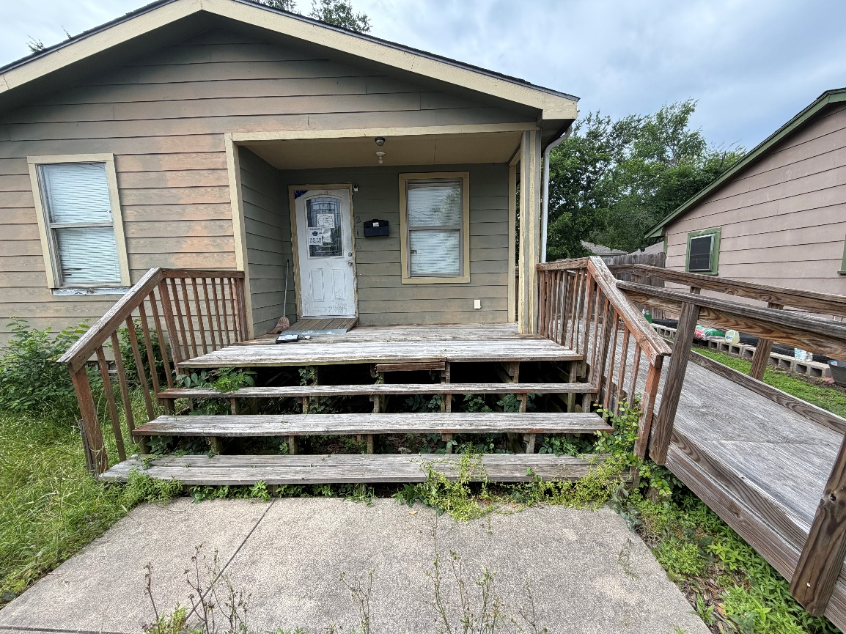
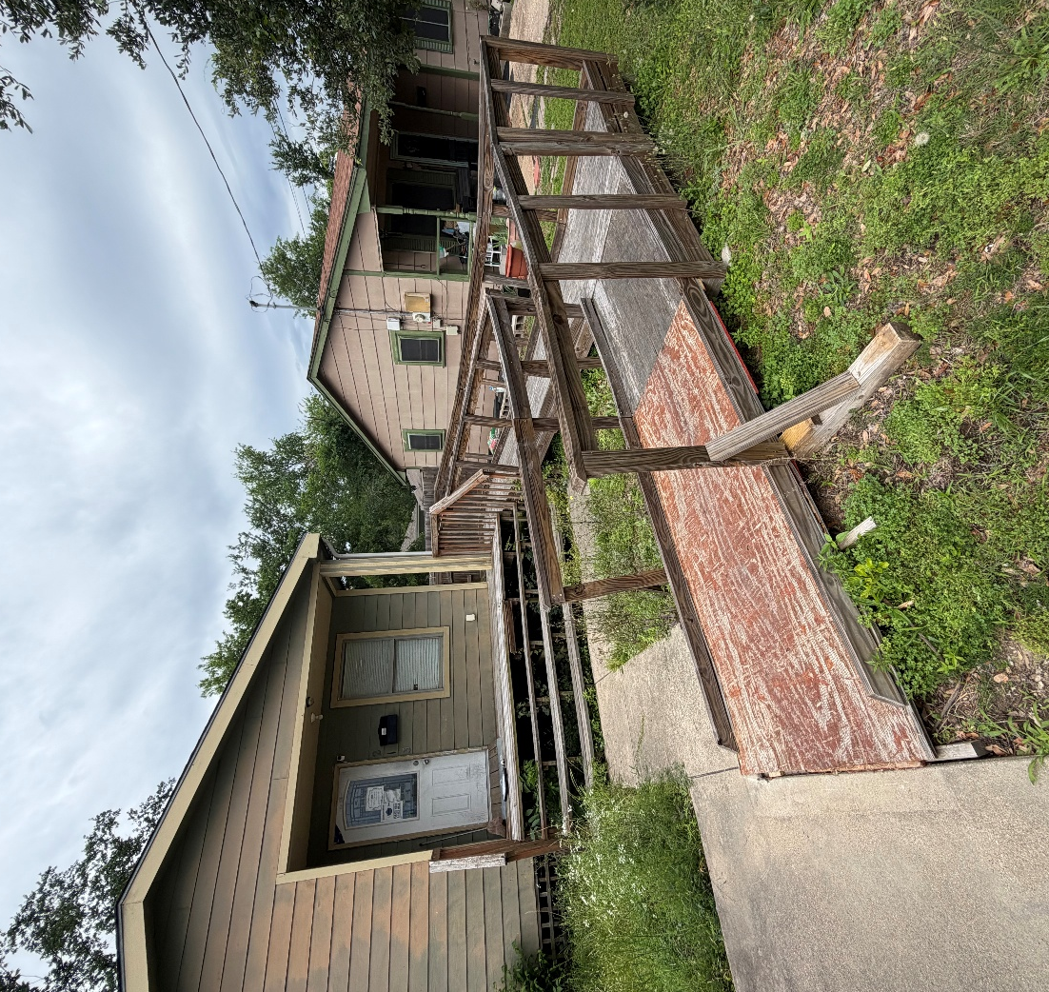
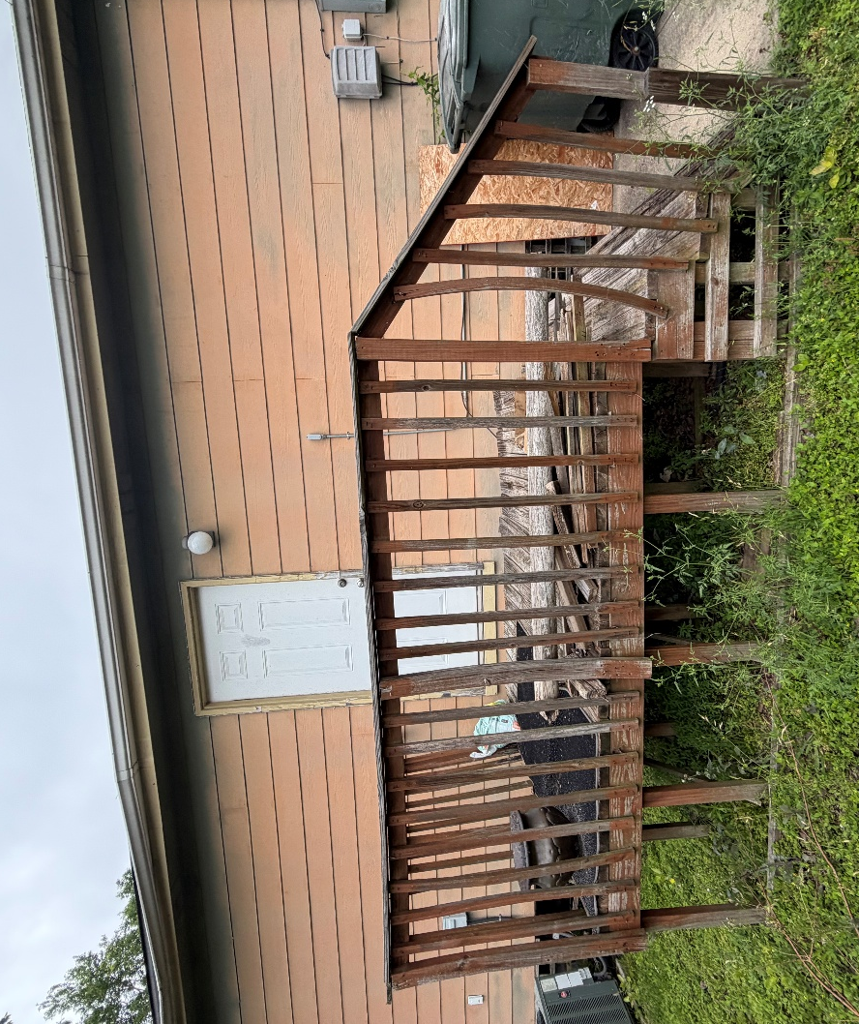
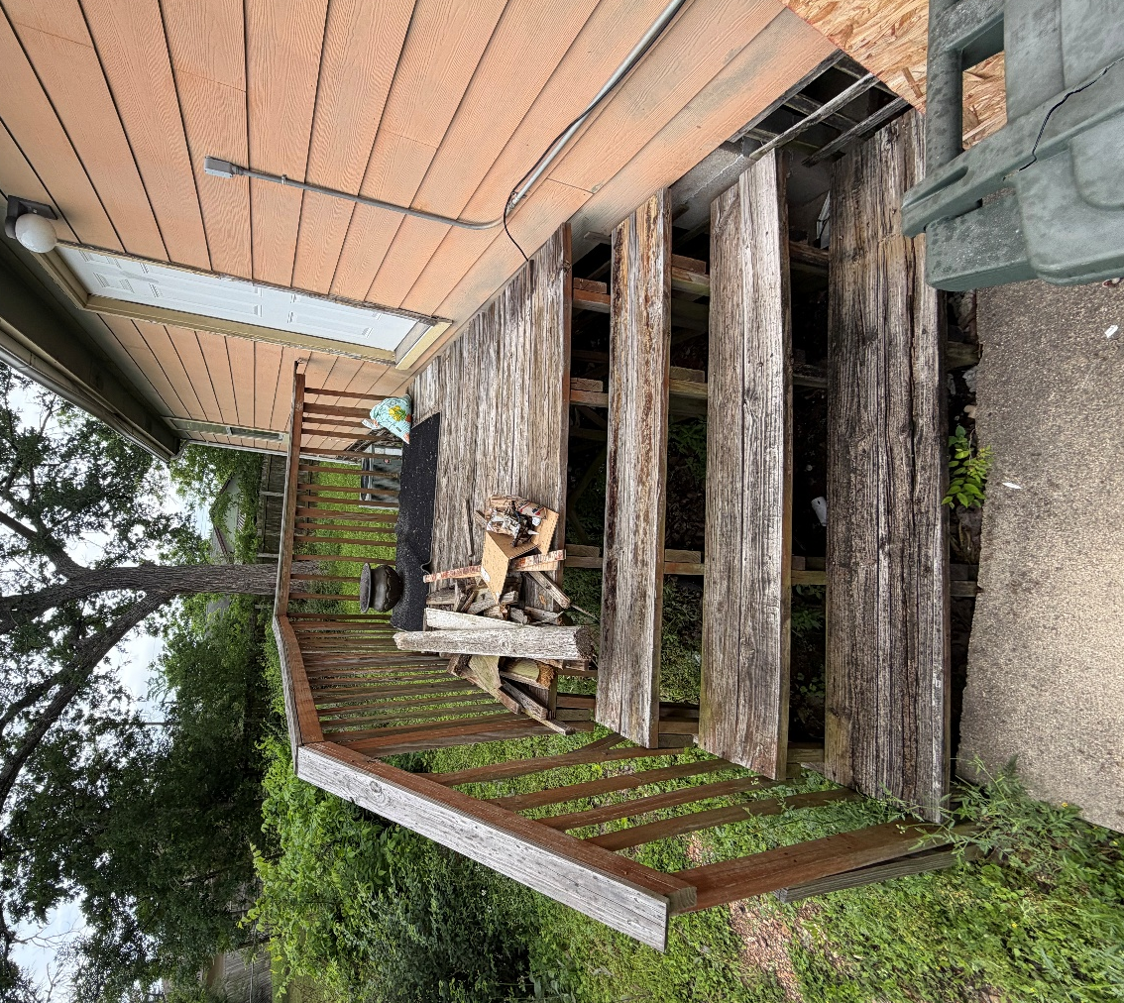
Rendered Project - “A” Ramp
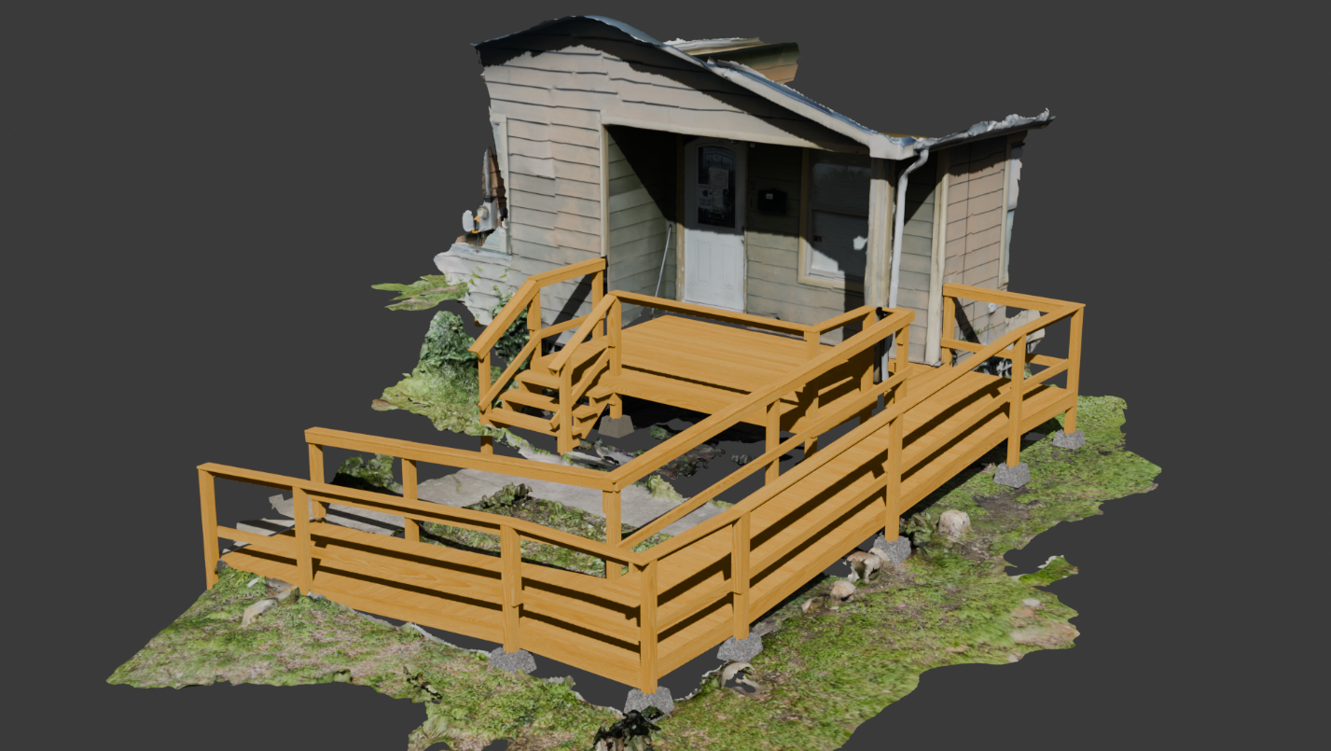
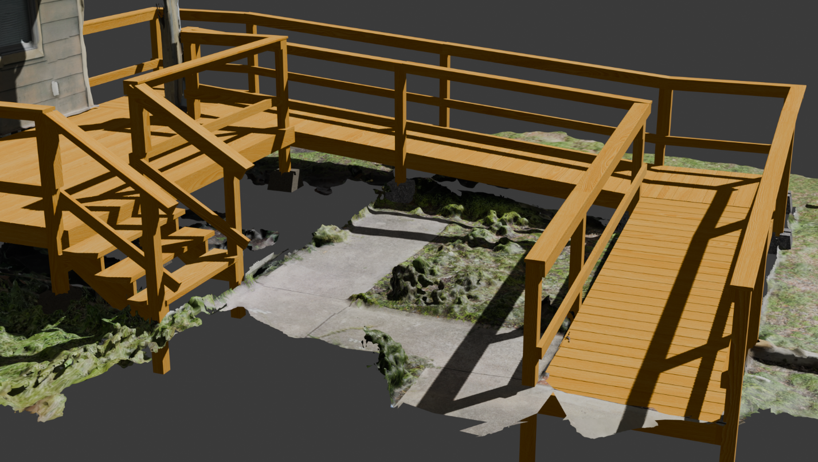
Rendered Project - “B” Front deck
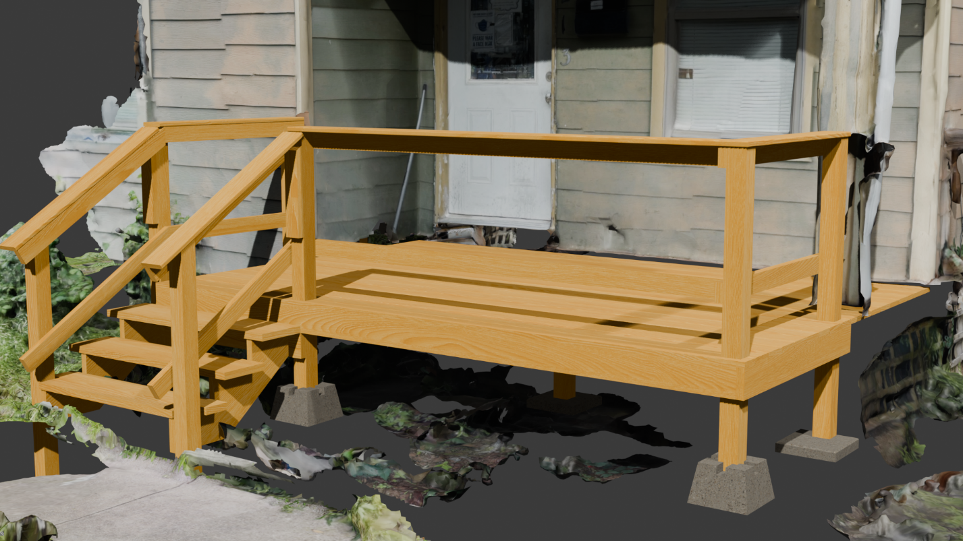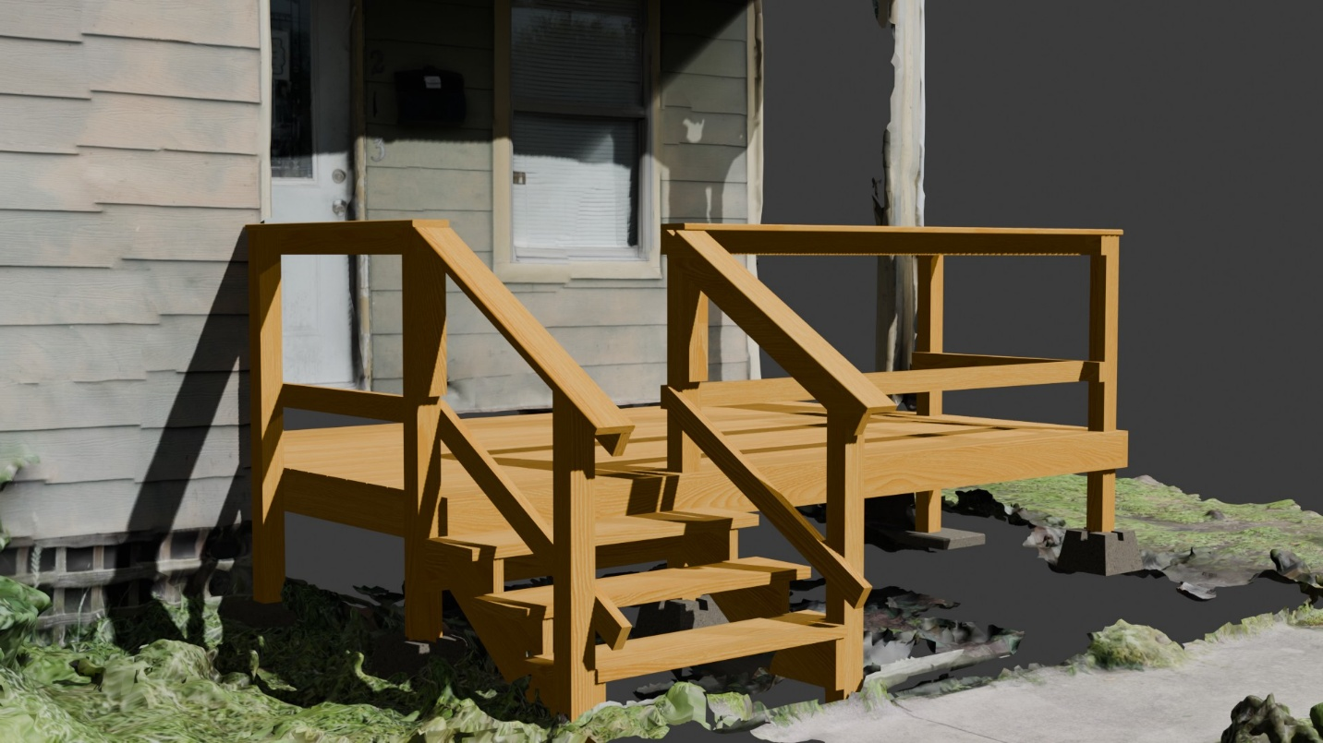

Rendered Project - “C” Back deck
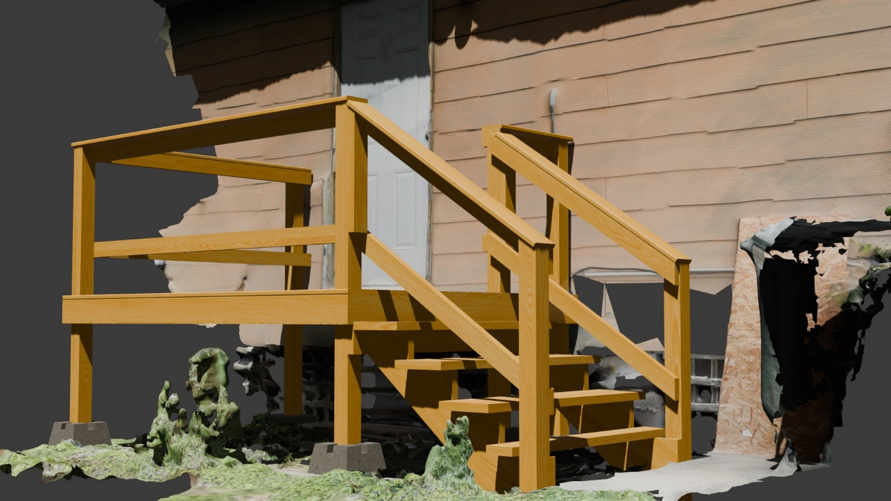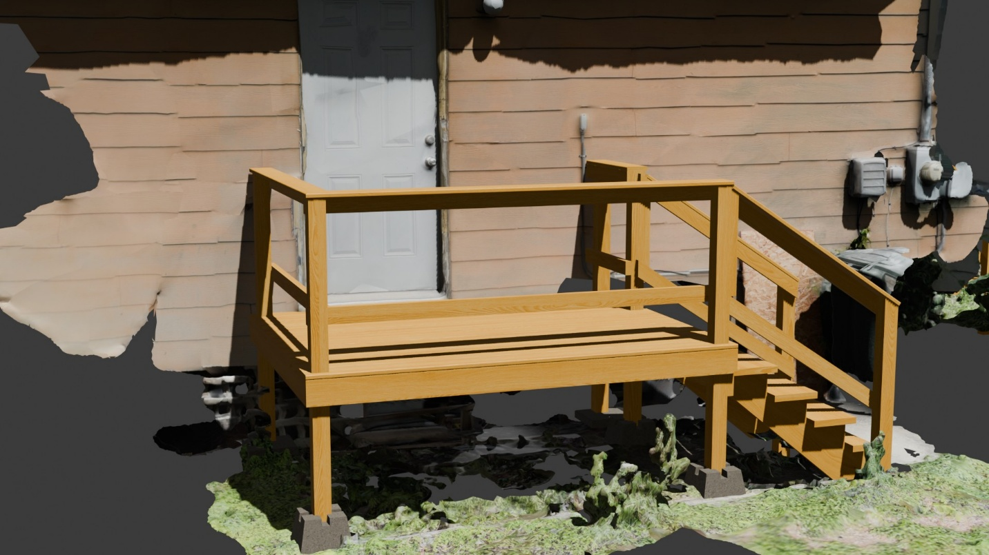

Building Notes
- Project A Ramp
  - The deck transition to the ramp is the hardest part
    - Keep in mind the gutter
    - The deck can be any width, minimum is 55 inches
- Project B Deck
  - The first priority of this project is to determine whether a 2x4 frame with deck boards, or to redeck and build a threshold ramp
    - You are given no extra lumber and should be the first thing
  - Your extra 2x12 box is redecked with deck boards and make sure they line up if the house deck is redecked with 2x6s
  - Since the width of the box is 4ft, I do not have it using joist hangers
- Project C Deck
  - Make sure the deck is next to the house
  - The longer 12ft 2x12 should be used on this house

